Bài tập Tuần 3
Họ và tên : Lê Thị Hoài Thương
MSSV: 23IT.B218
Link github: THUONGVIP09/Xu_Ly_NNTN
Code:
import requests
import re
from bs4 import BeautifulSoup
#bai1
url='http://forum.ehou.edu.vn/index.php?threads/chia-s%E1%BA%BB-t%C3%A0i-li%E1%BB%87u-h%E1%BB%8Dc-t%E1%BA%ADp-cho-m%E1%BB%8Di-ng%C6%B0%E1%BB%9Di.2556/page-2'
response = requests.get(url)
soup = BeautifulSoup(response.content, 'html.parser')
getdiv1=soup.find('form',{'class':'InlineModForm section'})
getdiv2=getdiv1.find_all('li',{'class':'message'})
output=set()
file=open("output_bai1.txt","w",encoding="utf-8")
for div in getdiv2:
text = div.get_text(" ", strip=True)
output.add(text)
for item in output:

email=r'[a-zA-Z0-9._%+-]+@[a-zA-Z0-9.-]+\.[a-zA-Z]{2,}'
item1=re.findall(email,item)
if item1:
print(item1)
file.write(str(item1)+"\n")

phone=r'[(\+84|0)\d]{9,10}'
item2=re.findall(phone,item)
if item2:
print(item2)
file.write(str(item2)+"\n")

file.close()
#bai2

url1='https://vietnamnet.vn/ngoi-lang-dam-chat-tho-cach-ha-noi-200km-chup-anh-dep-mien-che-2484938.html'
response1 = requests.get(url1)
soup1 = BeautifulSoup(response1.content, 'html.parser')
getdiv4=soup1.find('div',{'class':'maincontent main-content'})
getp=getdiv4.find_all('p')

file1=open("output_bai2.txt","w",encoding="utf-8")
file2=open("Hà_Nội.txt","w",encoding="utf-8")
output1=set()
import underthesea
from underthesea import text_normalize, sent_tokenize, word_tokenize

for p in getp:
text = p.getText()
output1.add(text)
print(output1)
sent=[]
word=[]
from pyvi import ViTokenizer
for item in output1:
sentences = sent_tokenize(item)

for s in sentences:
sent.append(s)
file1.write(s+"\n")

words=ViTokenizer.tokenize(item).split()
for w in words:
word.append(w)
ghep=r'^[A-Z]+[\w_]+(?:_[\w_]+)+'
timtughep=re.findall(ghep,w)
if timtughep:
print(timtughep)
file2.write(str(timtughep)+"\n")
file1.close()
file2.close()

Kết quả:
- Lọc email và số điện thoại:
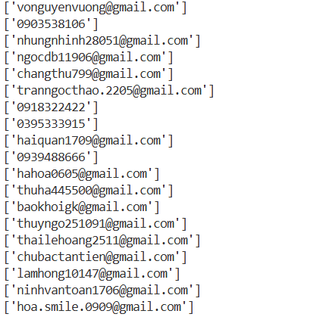

- Tách câu, lưu file
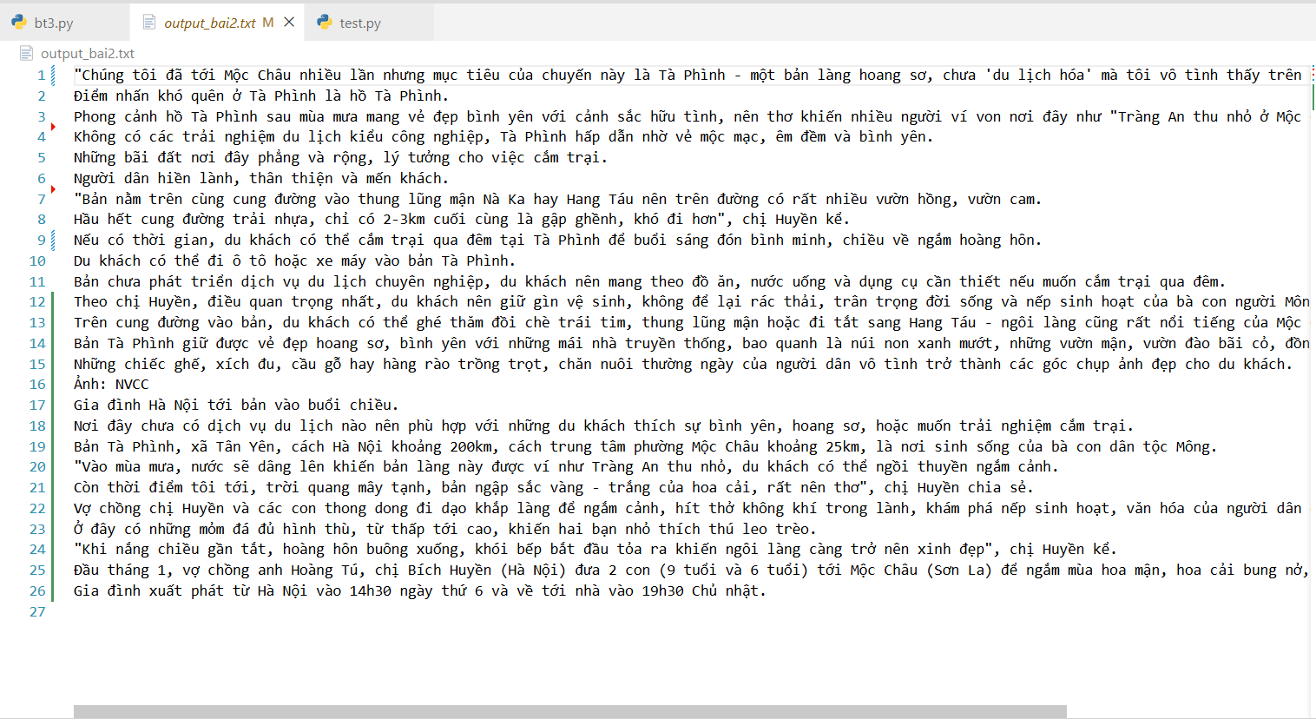
- Từ ghép liên quan đến địa điểm, lưu file
